**Batch 471: Day3 Terminal Commands – Practice Problems**

Question-02:

* mkdir abc def ghi jkl
* touch abc.txt def.txt ghi.txt jkl.txt
* mv abc.txt abc
* mv def.txt def
* mv ghi.txt ghi
* mv jkl.txt jkl

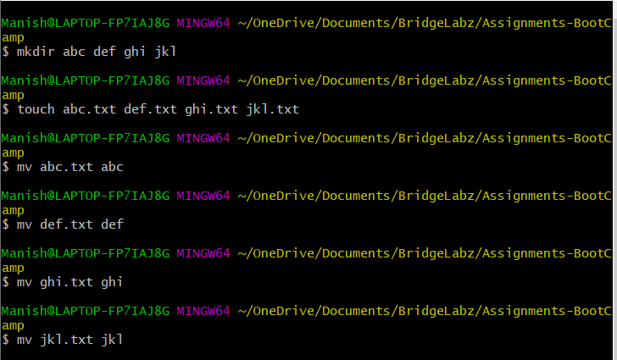

Question-04:

* find . -mtime +7 -ls

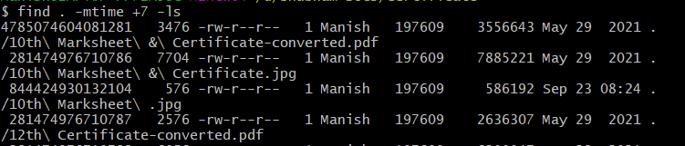

Question-05:

For file in *.txt

do

foldername=`echo $file | awk -F. ‘{print $1}’`;

echo $file;

echo $foldername;

if [ -d $foldername ]

then

“Folder already exist.”

fi

mkdir $foldername;

done

Question-06:

* Echo “hello”
* where hello
* ls
* where ls

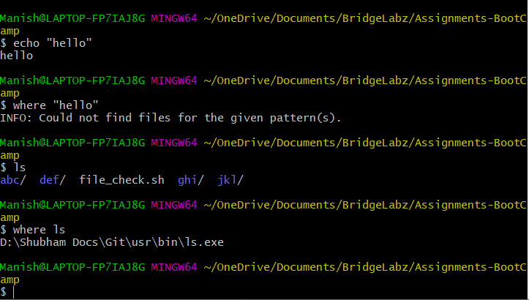

Question-14:

1. cat data.csv | awk ‘{if ($4 > 10000) print $2,$7;}’

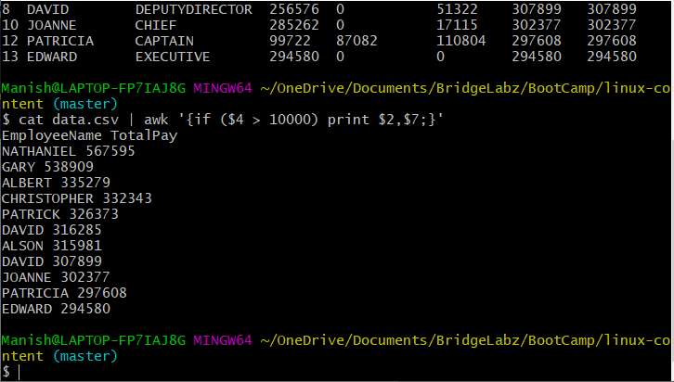

1. cat data.csv | awk ‘{if ($4 > 10000) print $1,$2,$3,$5,$6,$7,$8;}’

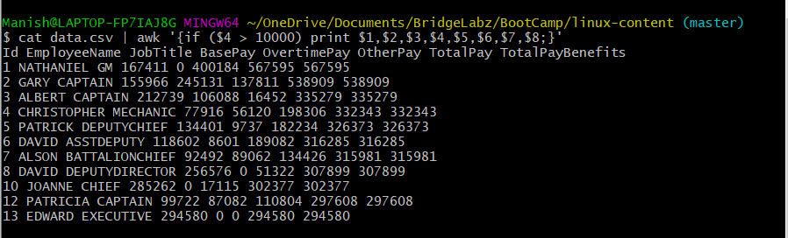

1. cat data.csv | awk ‘{print $2,$7}’

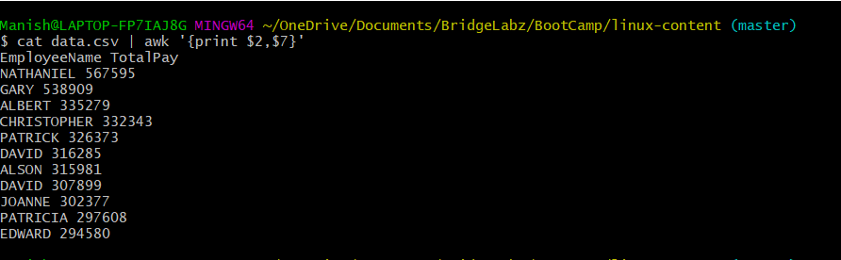

1. cat data.csv | grep CAPTAIN | awk ‘{sum+=$7} END {print sum}’



1. cat data.csv | grep CAPTAIN

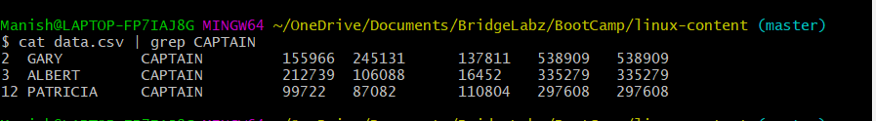

1. cat data.csv | awk ‘{sum+=$7} END {print sum}’

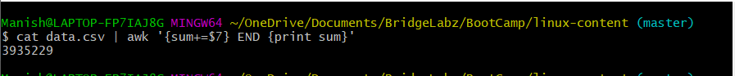

1. cat data.csv | awk ‘{if ($5>7000 && $5<10000) print $2,$3,$5}’

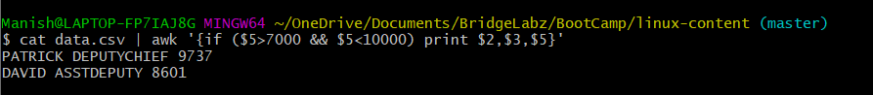

1. cat data.csv | awk '{sum+=$4}END {print sum/11}'

